Name :

Abubaker Attique

Roll no :

P20-0560

Section :

5-A

**Task 1:**

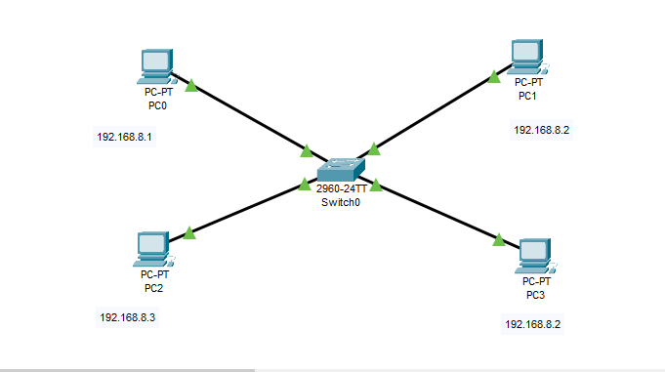

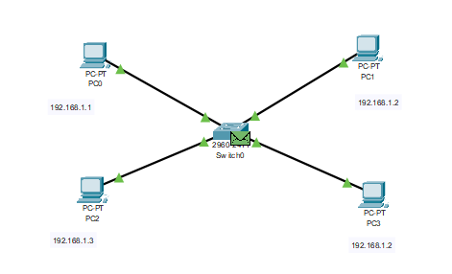

Description :

First we will construct switch & PC and connect PC’s with switch using Straight-through wire.After that we will assign IP addresses of type class C to devices .The host device receives the response from the switch.

Task 2:

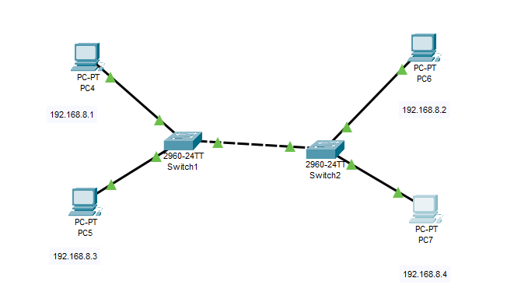

**Solution :**

Description :

We will construct 2 switches and 4 pcs and connect 2 PC’s with each switch using Straight-Through wire. After that we will assign IP addresses of type class C to devices.

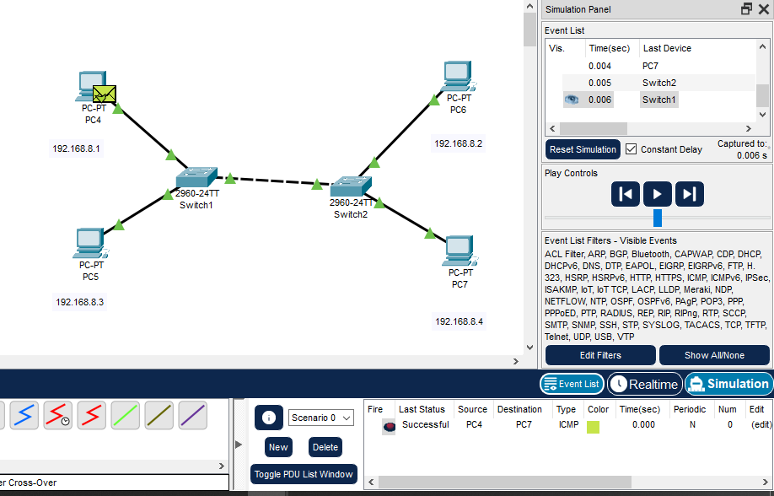

**Single router :**

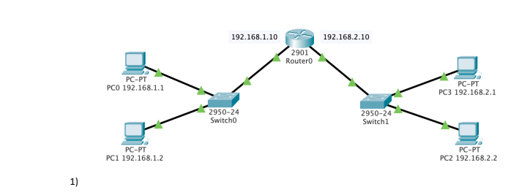

Solution :

Description :

We will construct 2 switches , router and 4 pc and connect 2 PC’s with each switch and connect both switches with router using Straight-Through wire.After that we will assign IP addresses of type class C .The host device will sends a packet to switch and switch will broadcast the packet. The router then sends a packet to the switch.The switch will sends a packet to the connected device.The switch then sends a message to the router.The router will sends a message to the switch and switch then it will send respponse to the host device.

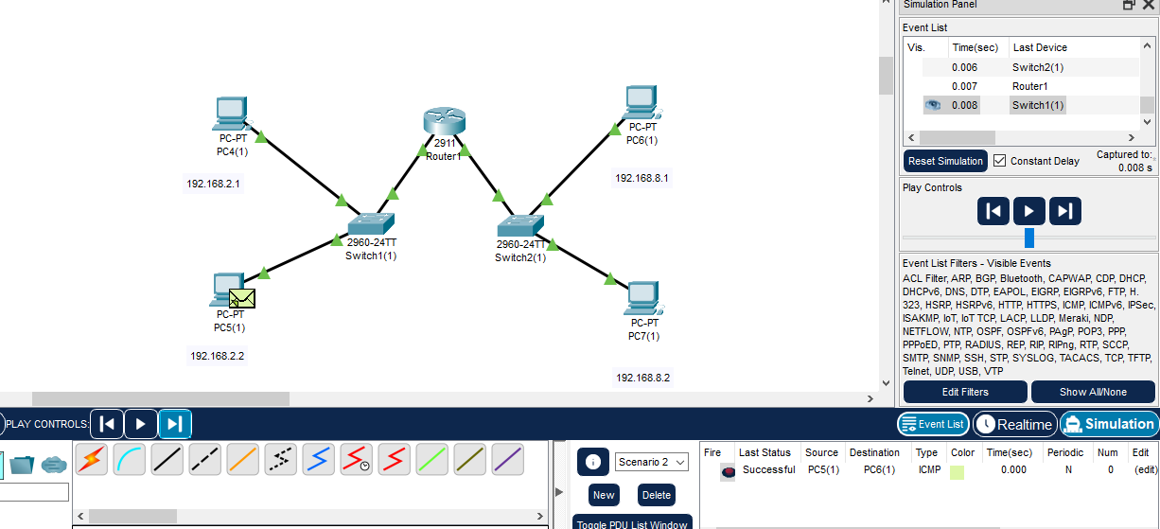

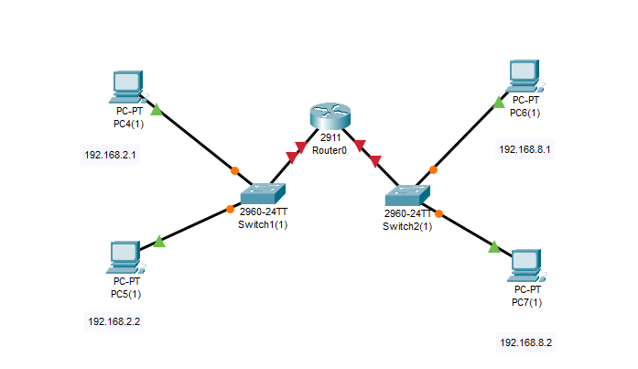

**Multiple router**

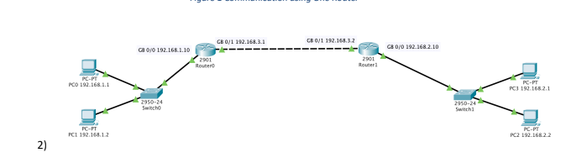

SOLUTION :

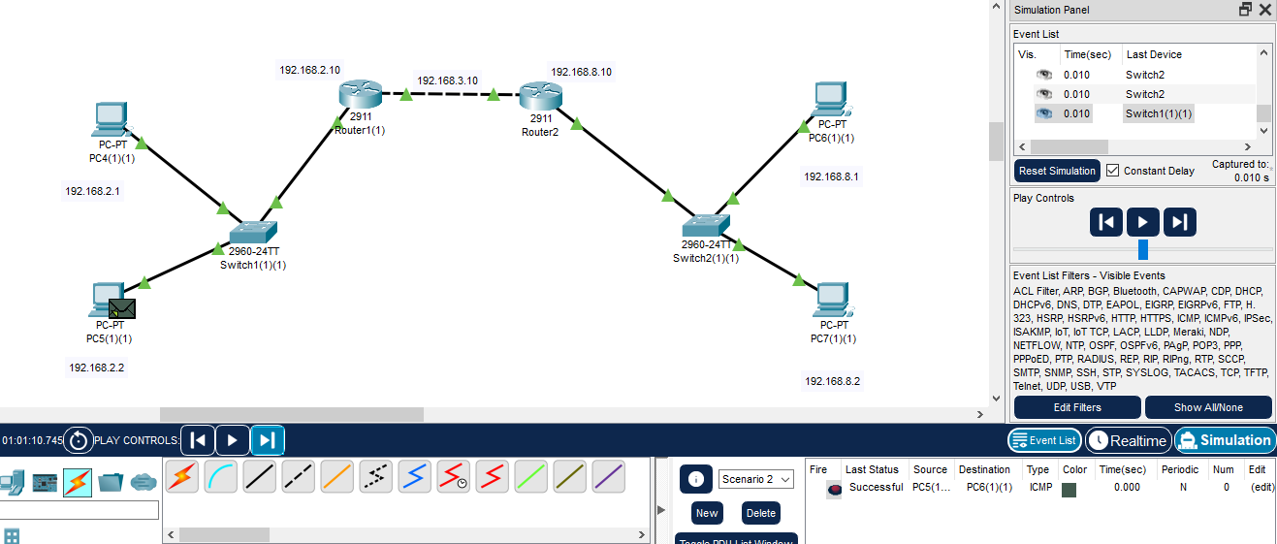

**Task 3 :**

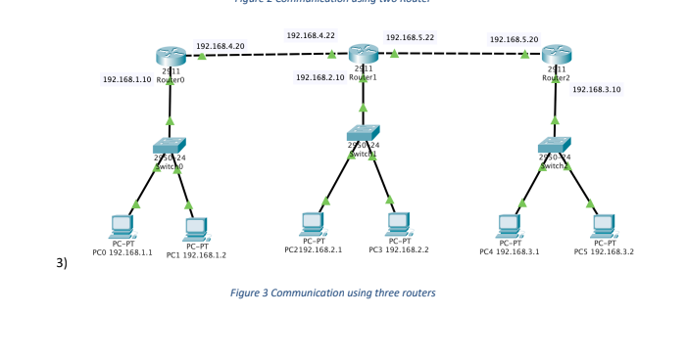

SOULUTION :

In task 3 we will construct 3 switches,routers & 6 pcs and connect 2 PC’s with each switch and connect switches with each router using Straight-Through wire.After connection we will assign IP addresses of type class C to devices .We will simulate in the simulation host device sends a packet to switch. Switch will broadcast the packet, Then the router sends a packet to the switch, the switch will again sends a packet to the connected devices.The switch then sends a response to the router.The router sends a response to the switch and switch then responds to the host device.And we will see the successful in the simulation as well.

